The Chocolate Machine
STEAM Challenge
Make a Chocolate Moving Machine Using 2 Simple Machines

STEAM Challenge – Build a Chocolate Machine

Chocolate Machine Challenge Rules - Rules sounds so official, but really there are only two: 1) Your machine must be able to move a piece of chocolate. 2) It must use two different types of simple machines to get the job done. But the biggest thing to remember here is that this project is about the process, not necessarily the end result. Because that’s where the learning happens.
ASK – What do you already know? What do you need to know to get started? Where can you find the information? ______________________________________________________________________________________________________________________________________________________________________________________________________________________________

Simple Machines
Let’s start with a little basic mechanical engineering – simple machines. A simple machine is a mechanical device that can change the direction of a force and they are considered the building blocks of all machines. There are six of these building blocks and here’s a quick description of each:
- Lever: A stiff board that rests on a center turning point called a fulcrum that is used to lift objects. Think teeter totter.
- Wheel and axle: A wheel with a rod attached to the middle can help lift objects. Think bicycle.
- Pulley: Adds a rope to a wheel allows you to change direction of a force. Think flagpole or window blinds.
- Inclined plane: A hard, flat surface with one end higher than the other. Aids in moving objects. Think slide.
- Wedge: Two inclined planes put together and helps push objects apart. Think axe.
- Screw: An inclined plane wrapped around a pole that can lift objects or hold them together. Think screw :)
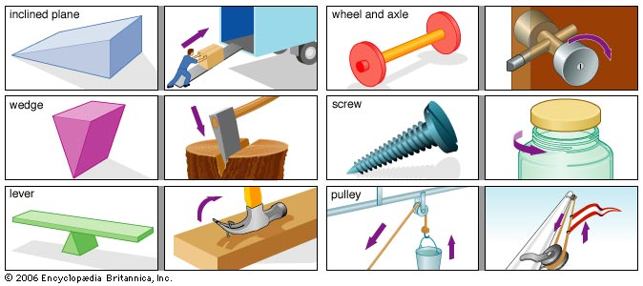

Chocolate Machine Supplies Needed
Now on to building your own machine. Here’s what you need.
- Design notebook or paper and pencil
- Cardboard and other recyclables like milk cartons, paper towel rolls, plastic bowls
- Materials that could be used for axles like dowel rods or PVC pipe
- Rope or twine for pulleys
- Screws and screwdriver
- Wood or other materials for wedges
- Cups or bowls
- Tape and/or glue
- Scissors

Imagine – What are the possibilities? Come up with several different options? __________________________________________________________________________________________________________________________________________________________________________________________________________________________________________

Plan – Choose an idea. Look at some of the examples below. Draw a model and label it. What 2 simple machines are you going to design and use? Plan out your design in your Science Notebooks.

Create - Next, build your Chocolate Machine. Follow your plan to create your model. What worked? What didn’t? What did you need to change as you went through your plan? Why? ______________________________________________________________________________________________________________________________________________________________________________________________________________________________

Improve – How could you improve your model? Do you need to start over, or can you redo a single part? If it works, can it work even better?

______________________________________________________________________________________________________________________________________________________________________________________________________________________________

Communicate – How well did it work? Is the problem solved? Write a statement to describe how your model meets the guidelines of the task and why it is successful.

__________________________________________________________________________________________________________________________________________________________________________________________________________________________________________

