Name: _____________________________________

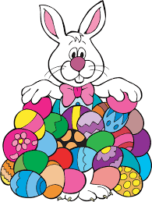
Kindergarten Engineering Project

Easter Egg Trouble

Name: ______________________________________ Engineering/Force and Motion
Step 1 - Ask

Problem: The Easter Bunny has too many eggs to carry.
Assignment: Design a way for the Easter Bunny to move his eggs.

What questions do you have that will help you complete this project? What do you need to know before you begin?

- ___________________________________________________

___________________________________________________

- ___________________________________________________

_________________________________________________

Part 2 - Imagine

Problem: The Easter Bunny has too many eggs to carry.
Assignment: Design a way for the Easter Bunny to move all of his eggs.
Imagine 2 different ways to move the eggs. Draw and label your idea. Give the idea a number or name.

Imagine a way to move the eggs.

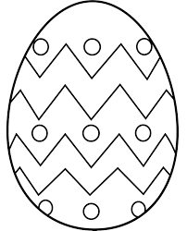
Step 3 - Plan

1. Choose the design you imagined that you think will work the best.
2. Share your plan with your partner:
A.  Tell your partner which materials you used. | B.  Tell your partner how to build it. | C.  Tell your partner why you think it will work.
3. Talk about each design. Compare the projects.
D.  Talk about the materials. | E.  Talk about why a design will or will not work. | F.  Talk about building the design.
4. Come to a consensus on which design you will create for your project.
5. We will choose:

Step 4 - Create

- Create your project with your partner.
- Use your project to move the eggs for the Easter Bunny.

Tell what happened.
___________________________________________________

___________________________________________________

___________________________________________________

___________________________________________________

___________________________________________________
Step 5 - Improve

How can you improve your project?

- ___________________________________________________

___________________________________________________

- ___________________________________________________

__________________________________________________

- ___________________________________________________

___________________________________________________

- ___________________________________________________

__________________________________________________

